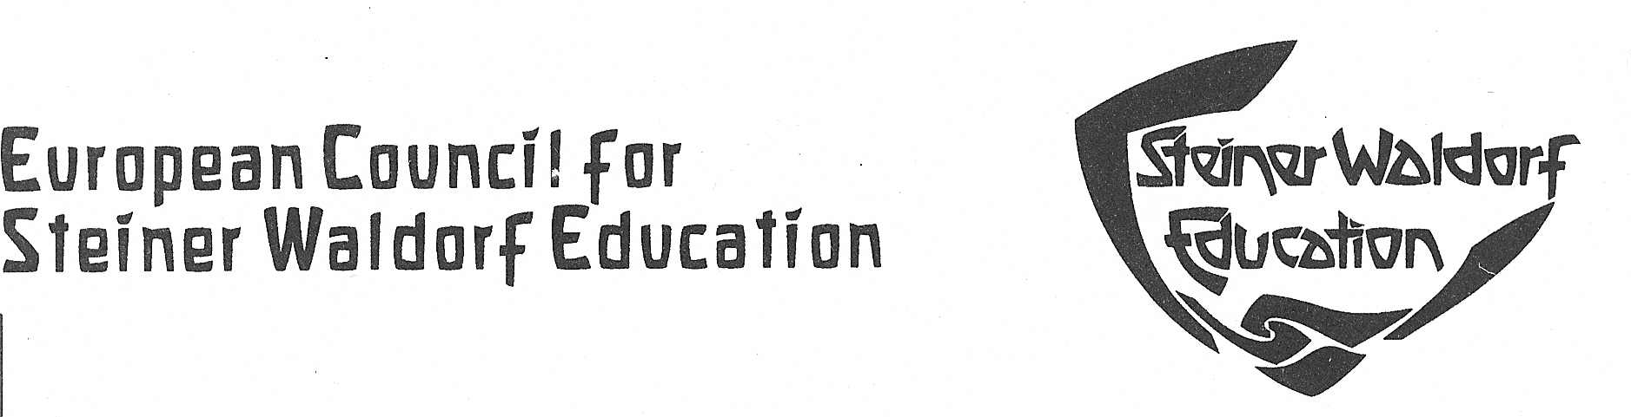

ECSWE NEWS n.4 06/07/06

1/ 12th EARLI Biennal Conference
The European Association for Research on Learning & Instruction (EARLI) will have its 12th EARLI Biennal Conference in Budapest, Hungary, from the 28th August – 1st September 2007, to which we have been invited.
The theme of the conference, Developing Potentials for Learning, has at least two levels of meaning: the growing importance of enriching the potentials of learning and the unidirectional trend of increasing possibilities in educational systems both play an important role in educational research.
If somebody is interested in attending the conference on behalf of ECSWE, we will make a contribution towards their expenses. If interested please contact the office.
The application form is in the Web Site: http://www.edu.u-szeged.hu/earli2007/

2/ New publication: “Becoming a teacher: Steiner’s Indications for Teacher Education, Development and Training” by Johannes Kiersch
ECSWE, in collaboration with the Comenius MA project, was financially supported in publishing a book with EU Comenius funds. It is a translation of an earlier work by Johannes Kiersch which has been substantially revised for the English edition, entitled “Becoming a Teacher: Steiner’s Indications for Teacher Education, Development and Training”. The book deals with Steiner’s evolving ideas regarding the training of teachers for Waldorf schools and professional development combining freedom with academic research, inner development, conscious responsibility, effective colleagueship and artistic sensibility and skills. It is distributed by the Steiner Schools Fellowship (SSF) publications at the cost of £6 from the Fellowship office (email. info@steinerschoolbooks.com).

3/ Summer School for Waldorf Teachers from Eastern Europe
I have just returned from the first days of a week’s Summer School that our Norwegian colleagues, with Astrid Bjøness’ leadership, have been running for the last five years for Waldorf teachers from Eastern Europe. This time the 60 participants were hosted by the Adazi School in Latvia, many arriving after long and arduous journeys in order to keep their expenses down. The impression is one of great warmth and enthusiasm and many friendships built up over the years of attendance. The mood was, in fact, festive, with lectures that were rich in imagery, experience and humour. The Norwegian Association also generously finances the accommodation and conference costs. Hopefully this initiative will be sustained for many years to come as it presents an international form of continuous professional development that is of immense value through developing a greater understanding of the Waldorf impulse and curriculum and creating a cheerful social interaction among the participants from many countries.
Christopher Clouder

4/ New DVD on Steiner Waldorf Education: “What is a Steiner School?”
The Steiner Waldorf Schools Fellowship has produced a DVD on Steiner Waldorf Education. The DVD is distributed by the Steiner Schools Fellowship (SSF) publications at the cost of £6 from the Fellowship office (email. info@steinerschoolbooks.com).

5/ New EURIDICE publication: “Quality Assurance in Teacher Education in Europe”
This study analyses processes for evaluating and accrediting initial and in-service teacher education programmes and institutions. It provides a general overview of the existence of regulations on external and internal evaluation in different countries as well as specific information on the main features of theses processes and the use made of their findings.
Document and press release:
http://www.eurydice.org/Doc_intermediaires/analysis/en/teachers.html

6/ Europe Loosing sight of Lisbon?
While noting positive trends in certain areas, the overall progress of Europe´s education and training systems towards the goals set in the Lisbon strategy is insufficient.
This is the main finding of the 2006 edition of the European Commission´s annual report on progress towards the Lisbon objectives in the field of education and training. The staff working paper analyses progress achieved since 2000 and focuses on five education benchmarks. On the positive side, Member States have successfully increased the number of tertiary-level maths, science and technology graduates. However, progress was only moderate in increasing participation in lifelong learning and in reducing the number of early school leavers. And little or no progress has so far been achieved in expanding the share of young people who finish upper-secondary school, and reducing the number of 15-year-olds with poor reading skills.
Ján Figel´, European Commissioner for Education & Training, said that "Education and training are vital for achieving the goals set in 2000 by the European Council at Lisbon. Consequently, the Member States agreed to work towards common objectives for their education and training systems and that their progress would be monitored against a set of five benchmarks that are key pillars for improving education and training in Europe, It is clear that additional efforts are urgently needed to achieve the five benchmarks by 2010.
Among the main findings of the report:
1. In the EU, about 6 million young people (18-24 years olds) have left education prematurely (2005 data). To reach the European benchmark of no more than 10% early school leavers, then 2 million of these young people would need to continue in education.
The majority of Member States must increase their efforts in the coming years to help reach the EU target. The best performing EU countries as regards the share of early school leavers are: Poland (5.5%), Slovakia (5.8%) and the Czech Republic (6.4%).
2. If present trends continue, some 1 million students will graduate in maths, science and technology (MST) every year in the EU in 2010, compared to the present level of 755 000 graduates.
The best-performing countries in terms of MST graduates per 1 000 of the population aged 20-29 are: Ireland (24.2), France (22.2), and the UK (21.0), while in terms of female graduates Estonia (42.5%), Cyprus (42.0%) and Portugal (41.5%) have the highest proportion.
3. In order to achieve the EU benchmark of an 85% upper-secondary school completion rate by 2010, an additional 2 million young people (aged 20-24 years) would need to complete upper-secondary education.
The best-performing EU countries are: Slovakia (91.5%), Slovenia (90.6%) and the Czech Republic (90.3%).
4. An additional 4 million adults would need to participate in lifelong learning within any four week period in 2010 if the EU benchmark of 12.5% participation rate is to be achieved.
The best-performing EU countries in this regard are: Sweden (34.7%), United Kingdom (29.1%) and Denmark (27.6%)
5. About one in every five 15-year-old pupils in the EU is presently a poor reader. Reaching the European benchmark for 2010 would imply that 200 000 pupils would have to improve their standard of reading.
The EU has still a long way to go to reach the objective set by the Council of reducing this percentage by 20% (to reach 15.5%) by 2010. The best-performing EU countries are: Finland (5.7%), Ireland (11%) and the Netherlands (11.5%).
6. The EU would need to more than double the amount it invests per tertiary-level student (i.e. an increase of around 10 000 euros per year) to match the spending level in the USA.
Public investment in education and training as a percentage of GDP has grown slightly since the adoption of the Lisbon strategy, and is comparable with levels in the USA (and higher than in Japan). However, rates of private investment in educational institutions are modest in most Member States compared with the leading countries in the world (incl. the USA), especially in higher education.
7. During the coming 10 years, the EU needs to attract at least 1 million newly qualified teachers in order to replace those who will leave the profession due to retirement.
8. Most EU students are not taught at least two foreign languages from an early age, as requested by the Barcelona 2002 European Council.
At present (2003 data), an average of only 1.3 and 1.6 foreign languages per pupil are taught in the Member States in general lower- and upper-secondary education respectively.

7/ ECSWE meetings
11-12th July 2006 – Brussels - Prep group and political work
15-17th September 2006 – Avignon – Council meeting – “Waldorf in areas of deprivations and needs”
19-21st January 2007 – Krakow – Council meeting – “Waldorf in emerging civil societies”
11-13th May 2007 – Kiev – Council meeting

Chiara Carones and Christopher Clouder

